Nā māua noa, nā
Jen Thomas & Margareth Broodkoorn

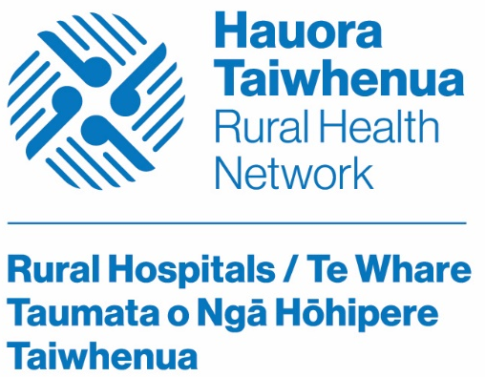 | Jen Thomas & Margareth Broodkoorn  Rural Hospitals Co-Chairs  Hauora Taiwhenua Rural Health Network  Incorporating NZLocums & NZMedJobs - experts in medical recruitment  Level 2, 88 The Terrace | PO Box 547 | Wellington 6140  www.htrhn.org.nz  Growing Healthy and Thriving Rural Communities

